**Arm Template Deployment modes**

Arm template for service bus namespace, topic and subscription created in incremental mode

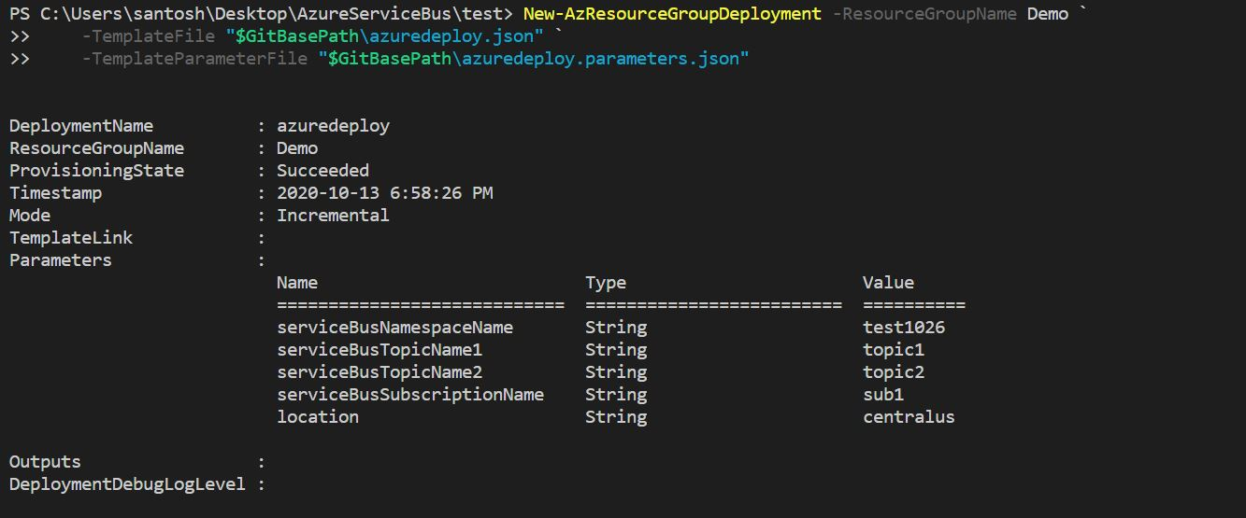

Same template deployed with different topic name but deployed in incremental mode, so another topic added to the namespace

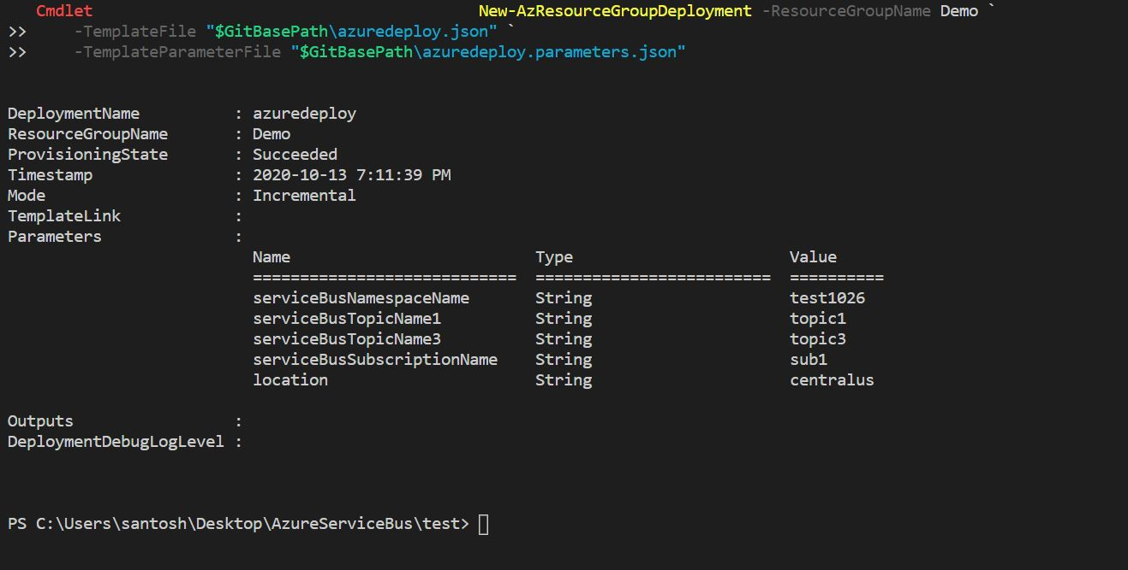

Deployed the same template in different Resource group with Complete mode

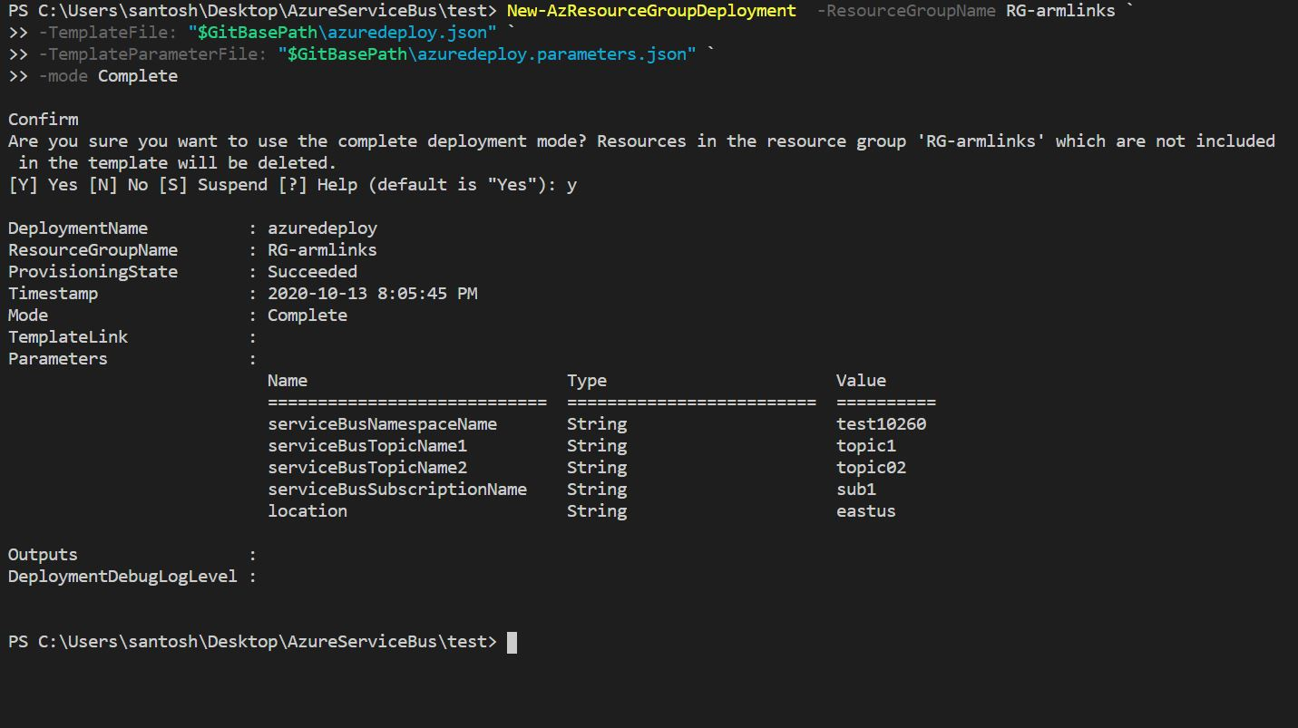

Did a Roll back to previous deployment “test02” with default Incremental mode

so resources present in the template added to the resource group

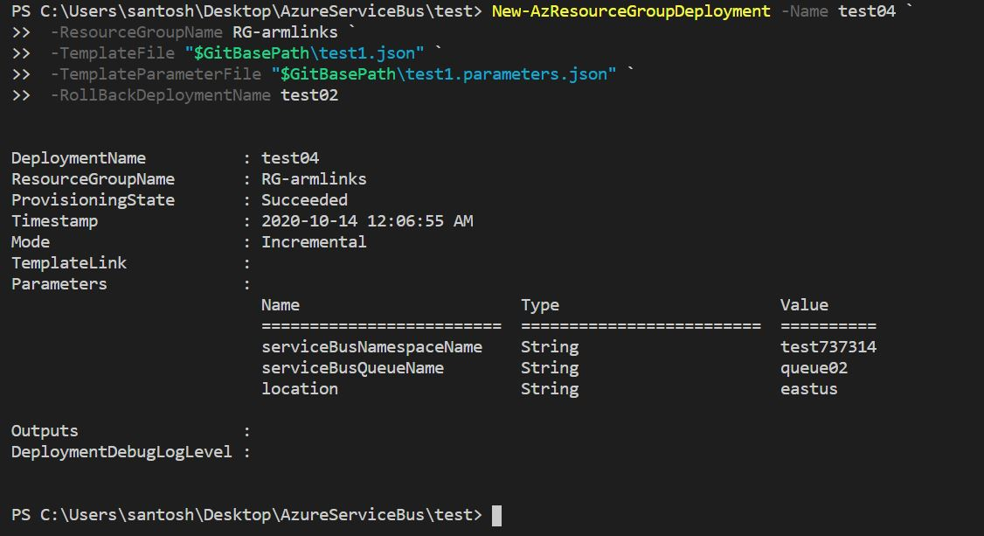

Roll back to previous deployment “test02” with Complete mode

The observations are other resources got deleted but queues still exist in the namespace and current template queue added to the namespace

